**LEAF Method 1313 Validation**

A validation exercise using LEAF Method 1313 data was performed and is included here to illustrate a GEM application using multiple SVs, a “dynamic sorption” assumption, and a minimal number of GEM compartments. The Method 1314 validation exercise was implicitly based on an assumption of instantaneous equilibrium between sorbed and dissolved phases, quantified in the partition coefficient Kd. In this exercise, we use a more general assumption that the sorbed and dissolved concentrations do not necessarily achieve instantaneous equilibrium. Method 1313 is a batch experiment that measures chemical release from solid materials as a function of pH. It is performed by tumbling the material at a LS ratio of 10 (ml extractant/g dry sample) for 1 – 2 days and subsequently evaluating the dissolved chemical mass in the extractant. It is then repeated at different pH values. The Method 1313 data used here were obtained from experiments performed at EPA’s National Risk Management Research Laboratory in Cincinnati, Oh (Al- Abed, personal communication, February 2016). The materials used for this Method 1313 experiment were crushed mine tailings. The measured chemical element used for this analysis is aluminum, Al, and the experimental pH was 2.13.

A minimally simple, 2-compartment, GEM structure for this application was used. Compartment 2 is the (400 ml) Method 1313 batch reactor vessel. Compartment 1 is a GEM “dummy” compartment and is included because the minimum number of compartments for GEM applications is 2. No advective flow or dispersive transport occurs between compartments 1 and 2; therefore, compartment 1 does not enter into the PDEs representing this application, but is included simply to satisfy the GEM minimum number of compartments (2).

Two SVs (SV) were simulated. SVs 1 and 2 are dissolved and sorbed Al, respectively. The dynamic sorption/desorption formulation treats sorption from SV 1 as a 1st order sink with respect to SV 1 and first order source with respect to SV 2. Similarly, 1st order desorption is a sink from SV 2 and a source for SV 1. If the 1st order sorption and desorption rate constants (1/day) are denoted as ks and kds, respectively, then it can be shown (e.g., Schnoor, 1996; Little, 2012) that, at equilibrium, ks and kds are related to the dissolved fraction, Fd, as

 (1)

where (equilibrium) Fd can be determined as a function of experimentally measured water content, bulk density, and Kd from



Using the experimental values for these parameters, the ks/kds ratio was calculated from equation (17) as 0.055/day. What we know therefore are the relative values of the sorption and desorption rate constants, but not their absolute values, i.e. we should be able to simulate the equilibrium concentrations but will not know how long it takes for that equilibrium to occur. Nonetheless, we arbitrarily assigned a value of 0.1/day to kds and calculated the (relative) value of ks = 0.0055/day. Envisioning the initial conditions in the Method 1313 batch bottle immediately upon introducing liquid, but before any desorption has occurred, we assigned an initial condition for SV 1 (dissolved Al) as 0 g/m3. For SV 2 (sorbed Al), an initial (volumetric) concentration was calculated based on the initial total Al mass in the mining tailings sample, 230.4 g/m3. The GEM was then run for 100 days with a 1-day time step. The resulting time series concentrations are shown in Figure 1, along with a horizontal line representing the equilibrium, measured dissolved Al concentration at the end of the 1313 experiment, 216.4 g/m3. (Note that the measured, 216.4 g/m3 concentration is *not* a time series, but rather a single, equilibrium value.)

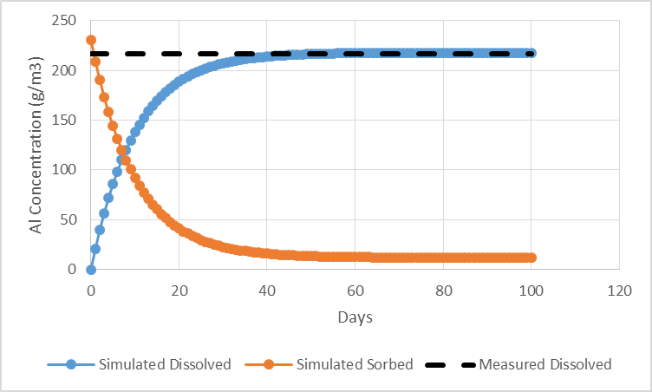

**Figure 1. Validation Exercise for Measured Al in EPA Method 1313 Experiment**

As expected, the sorbed concentration decreases from its initial value as desorption occurs while the dissolved concentration increases from 0 g/m3 to a steady-state, equilibrium value of approximately 218 g/m3. The simulated and measured equilibrium values are very consistent. Because the absolute values of the sorption and desorption parameters are not known, only their relative values, the time-to-equilibrium in the actual 1313 batch bottle could be very different than the approximately 30 days shown in Figure 1. However, the point of the exercise is to recover the equilibrium dissolved value which is accomplished. (Using relatively higher or lower values for the sorption/desorption parameters but still maintaining their ratio simply speeds up or slows down the time-to-equilibrium, but does not affect the equilibrium value itself.) Because we did not iteratively alter GEM parameter values in order to “fit” the data as in a calibration exercise, we consider this a validation exercise, as well as an illustration of additional GEM capabilities for dynamic sorption with multiple SVs.

**References**

Little, K.W. 2012. *Environmental Fate and Transport Analysis with Compartment Modeling*. CRC Press, Boca Raton, FL.

Schnoor, J.L, 1996. Environmental Modeling: Fate and Transport of Pollutants in Water, Air, and Soil. New York: Wiley